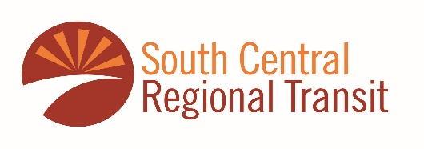

South Central Regional Transit District To Initiate Fare-Free Service

Las Cruces, New Mexico- The SCRTD Board at their December meeting approved a Fare Free bus service to begin on New Year’s Day. The district joins over 100 cities around the World that offer free public transit. All SCRTD bus services in Doña Ana County, including those connecting to El Paso will be Fare Free from January 1, 2024, until June 30, 2024.

Doña Ana Commissioner Manuel Sanchez said that now is the best time to encourage residents to try public transit, "According to the 2020 US Census, residents in rural counties such as Doña Ana spend about 20% of their household incomes on transportation annually. By offering a Fare Free service, we will allow those who drive today to experience SCRTD's safe and convenient service while saving on their family's budgets and helping us to improve our air quality."

This is one of many programs the district is evaluating for the coming year. SCRTD has expanded its services adding new routes, passenger amenities, and Google Transit to assist users in using the transit system. Further, the district will add electric-powered buses to its fleet as it transitions to a Zero Emission Bus Fleet within the decade.

Javier Perea, SCRTD Board Chair said, "Most other transit agencies in the nation have cut their service dramatically because of the pandemic, SCRTD has controlled its cost making it possible to provide free public transit. Offering free fares will allow more people to give SCRTD a try."

SCRTD route and schedule information is available at scrtd.org or by calling 575-323-1620.

About Doña Ana County
Doña Ana County is in southern New Mexico bordering Texas and Mexico. With a population of 219,561, it is the second-largest county in the State of New Mexico. The County seat is in Las Cruces and is the largest majority-Hispanic county in the state.

About SCRTD
SCRTD was formed in 2006 and began operation of service in 2016. The agency operates a regional transit service with eight routes that serve three counties carrying over 100,000 riders in 2023, a ridership increase of 20% over 2022. SCRTD services connect riders with Roadrunner bus service, El Paso's Sun Metro, and other local operators.

US Census 2020/USDOT Bureau of Transportation Statistics

