DRAFT PRESS RELEASE
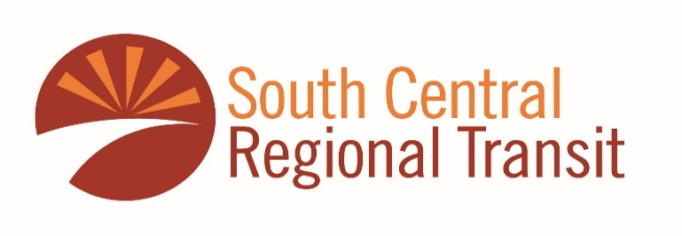

For Media Inquiries Call: Cristina Gamboa at (915) 841-9248 or (575) 323-1620

SCRTD Board Approves Transition to Zero-Emission Bus Fleet
The South Central Regional Transit District plans to be 100 percent emission free within the decade. On May 25th, the Board approved the district’s first zero emission fleet transition plan, which is required by the Federal Transit Administration to apply for federal funds supporting the replacement of buses. The State of New Mexico’s Transportation Department provided the district with grant funds for the development of the Zero Emissions Transit Plan.
This week, SCRTD submitted a $3.1 million dollar grant application to fund the first of three electric emission buses with charging infrastructure. If awarded, the first electric buses would begin running in March 2024.
The first electric buses will operate from the Sunland Park bus facility located at 295 Quinella, Sunland Park. David Armijo, Executive Director said, “The transition plan provides a guideline and target to reach district goals for making the fleet zero emissions by 2032.” “To reach this goal, the district will deploy both 25 and 35 foot buses to operate within the range possible with electric power.”
The District will partner with the El Paso Electric Company to support technical requirements to install and operate the electric buses from the Sunland Park facility. Electric Company engineering staff helped assist district staff in the development of the Zero Emissions Plan. Sunland Park Mayor Javier Perea reported, “the transit district’s plans will complement the city’s plans to move toward electric vehicle use and the community will benefit from cleaner running buses on our streets.”
Much of the funding in the plan will come from three sources, federal grants, Dona Ana County, and member agencies contributions.
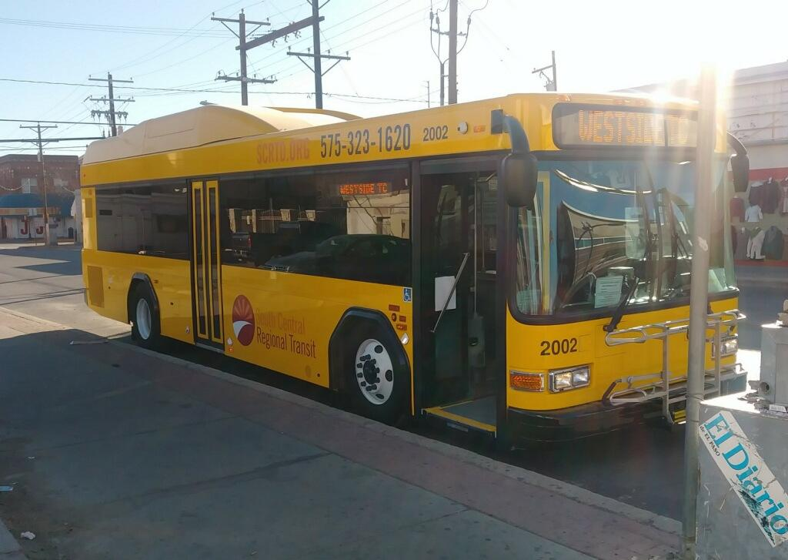
Hybrid-Electric bus operating in downtown El Paso on the Yellow bus route.

More details will be provided by calling our information line at (575)-323-1620.
You can view bus schedules at https://scrtd.org/all-lines/
If you would like more information about South Central Regional Transit District, you can visit our website at https://scrtd.org/

