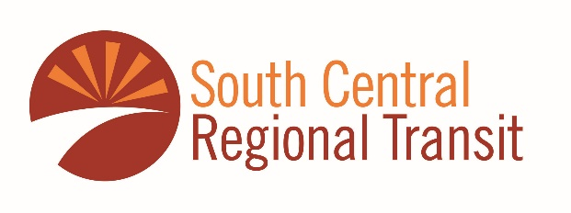
The South Central Regional Transit District has produced a three year transportation service plan that describes the services provided in South Dona Ana County including the cities of Anthony and Sunland Park, two transit service facilities and buses operating on the Turquoise, Purple, Silver, and Yellow bus routes. Below is the service area map.
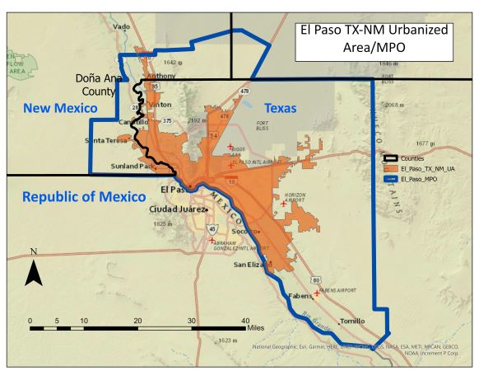
If you have any comments on the plan or on the current services provided, please complete the following survey form.
- Do you use the current bus service on either of the four routes listed in the service area?

- Which bus route do you use?

- How often do you take the bus?

- Are there any locations where you would like to see bus service added?

- Do you have a bus stop request for your community?

- Provide any comments you have on the Three Year Plan?

- Other thoughts?

