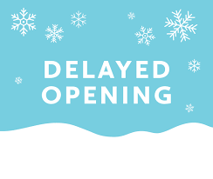
Due to inclement weather our transportation service will be on a two-hour delay for Thursday February 3, 2022.
Please call 575-323-1620 if you have any questions.
We apologize for any inconvenience. Stay Cautions!

