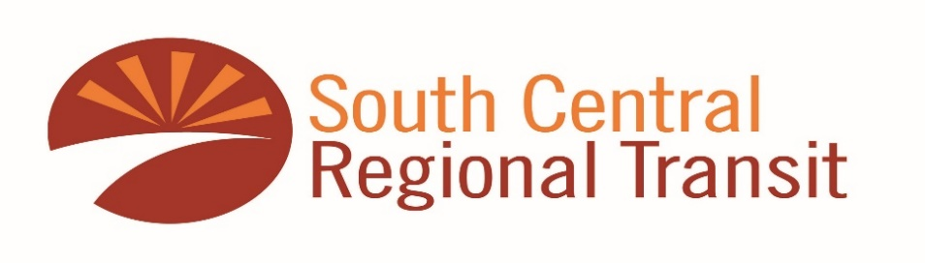
RIDER ALERT
WE WILL BE CLOSED ON SUNDAY, July 4th
for ALL routes.
The Yellow and Silver Routes will resume as usual on Monday, July 5th.
We will resume full service Tuesday, July 6th.
THERE WILL BE NO BUS SERVICE IN OBSERVANCE OF INDEPENDENCE DAY
THE REGULAR BUS SCHEDULE WILL RESUME ON TUESDAY JULY 6TH

THANK YOU FOR YOUR PATRONAGE

